St. John the Baptist Catholic Church
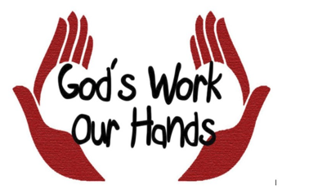
Outreach Ministry

“…whatever you did for one of these least brothers of mine you did for me.”
Matthew 25:40

Our Mission
In keeping with the teaching of Jesus Christ that we love and serve one another, the Outreach Ministry seeks to share the love of God with our parish family and the local community within our church parish boundaries, Catholic or not. We practice the corporal and spiritual works of mercy by providing emergency financial assistance and prayerful support to those in need, delivering food, visiting the homebound, elderly, and sick, comforting the grieving and welcoming newcomers to our parish. Our work is confidential and is funded by donations and the “Poor Box” located in the back of Church.
Ways We Can Serve You
- Provide financial assistance for those in crisis.
- Visit the homebound, sick and those who live alone.
- Easter Outreach.
- Sponsor St John’s Angel Tree for St. Tammany Project Christmas.
- Christmas Outreach.
- Provide meals when sick, after surgery, or childbirth.
- Help with simple repairs.
- Provide a listening ear and prayerful support in times of crisis or grief.
- Visit and sponsor a monthly activity at the Folsom
Council on Aging (COAST).
- Monthly delivery of a home cooked meal to families in the community.

If you or someone you know is in need of assistance or you feel called to serve in this ministry, please contact the church office at 985-796-3806.

